WebStorm + TypeScript Setup Guide

**After downloading my code from GitHub, here is how to setup WebStorm with TypeScript to be able to run my program:**

* Make sure you have installed Node and installed TypeScript with the command: npm install -g typescript
* Click File>Settings>

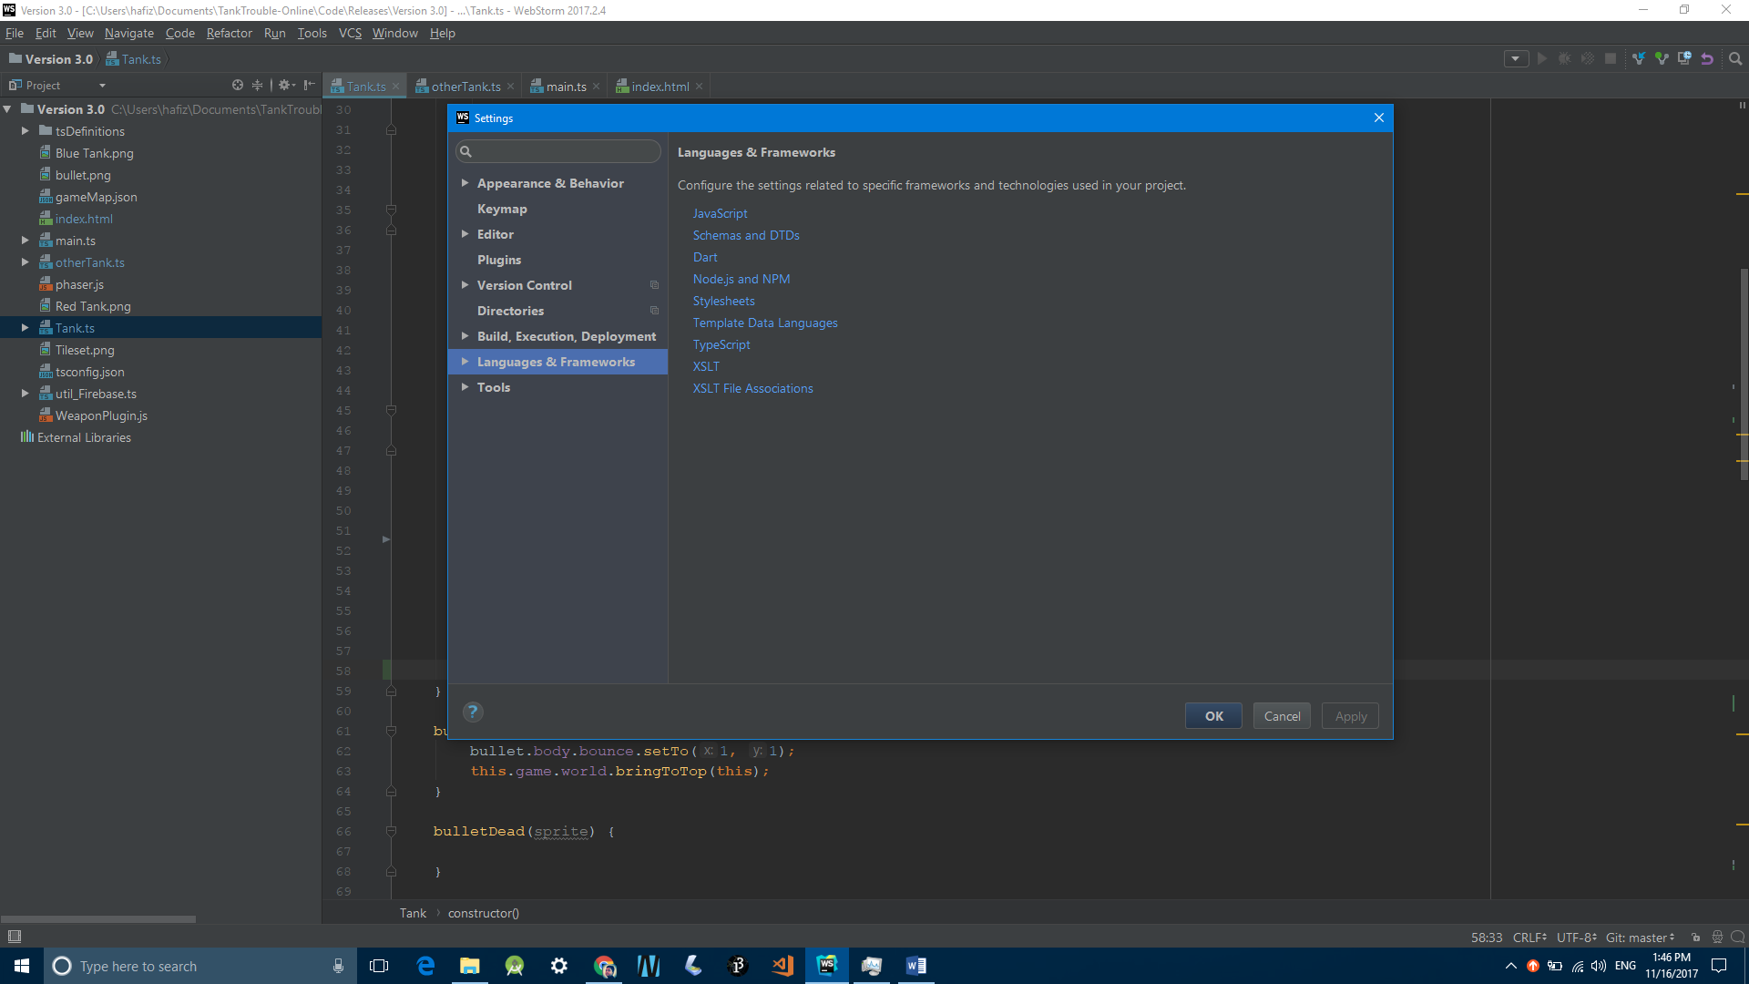

* Double click on Languages & Frameworks and then click on TypeScript
* Match your settings with the following:
* 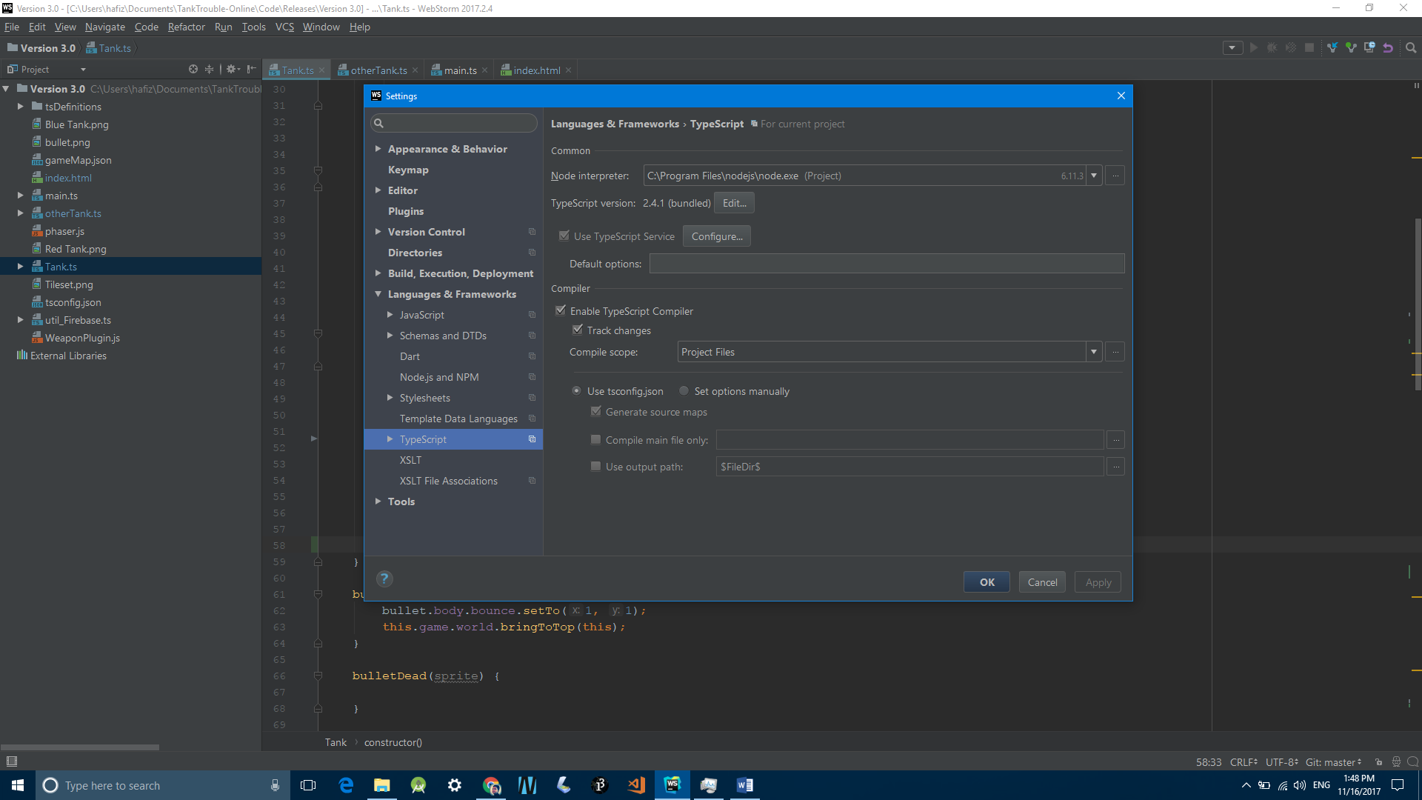
* To run the code, open index.html
* Hover in the top right corner of the screen and pick your favourite browser from the available list

